**1. INTRODUCTION**

An internship is thought to add a few encounters from the different associations, which will encourage bounty to connect the hypothetical and reasonable data. It includes profitable abilities like usable working environment or pc instrumentation, taking care of a spread of things in the meantime, sorting out or dissecting learning, spending plans or rising collaboration, composing, and talking gifts. A usable work environment or pc instrumentation, composing and talking gifts. It’s indispensable to get a handle on the best approach to impart data to outsiders, managers, and companions. Be that as it may, this is frequently not happy to get a handle on web development because it’s an extremely huge marketplace. To encourage sound data concerning programming which has net application style and Development. I'm intrigued to attempt and do an entry-level position. This entry-level position report covers the whole temporary job time that I have finished with progress concerning the coding, style, and improvement.

**1.2 Objectives**

**To secure an internship position as a marketing trainee with your organization**. Coming with exceptional skills and the ability to market products and advertise for the benefit of the organization. A self-motivated, hard-working, and positive student looking for an internship position.

* Understand basic concept and structure of HTML3, HTML4, HTML5, CSS, Bootstrap Framework, and JavaScript, creating Database & connecting.
* To get awareness about the various job opportunities.
* To perceive communicational skills and organizational dynamics.
* To get educated about the official habitat.
* Opportunities for technical skills.
* Improve communication skills.
* Knowing all types of official knowledge

**1.3 Goals**

I have been practicing all programming languages and skills which I have to get from Our School. It’s will help me a lot in my future while studying computer science files and also help me a lot .

* Knowing practical knowledge about programming.
* Gain knowledge about HTML3, HTML4, HTML5, CSS, Bootstrap Framework, Basic PHP, Java-Script etc.
* Increase communication skills with others.
* Gain essential background knowledge.
* Works well with others.
* Develop research skills.
* Improve administrative skills.
* Increase the capability for solving the problems.
* Knowledge of professional journals and newsletters.
* Knowledge of key professionals.
* Improve professional ethics and values.
* Improve technical skills.

**Management Summary**

* 1. **Activity Organization**

|  |  |  |
| --- | --- | --- |
| Position | People | Description |
| -Project Manager /Leader  -Documentation | -Ritesh Prasad Shah | -is responsible for ensuring that the project team completes the project. Also, develops the project plan with the team and manages the team’s performance and project tasks.  -it is also the responsibility of the project manager to assure acceptance and approval of deliverables from the stakeholders. |
| -Decision Making  -system Analyst  -Assigning Task | - Abhishek Singh | -responsible for communication, including status reporting risk management, issues that cannot be resolved in the team, and in general, making sure the project is delivered in budget, on schedule, and within scope. |
| -Designer & Developer | - Mumtaj Ali | -responsible for the coding.  -responsible for the design which will be decided  by the team.  -makes suggestions. |

**Table 1**: Activity Organization

**1.5 Scope**

In order to meet the project deadline, we the researcher formulated the scope of this project to identify the boundaries of this study. The website, which is going to be the output of the study, is simply going to transition Restoran method of promoting, informing and handling data to computerized one such as, allowing the students, parents and visitors to view some information of the institution, recording all the necessary information with regard from the students, has the capability to keep in track the records of the student, allowing parents and students to access anytime they want, and providing features that make the school part of a member’s daily functions.

**1.6 Limitations**

In making the website, limitations should be understood and planned for before the research process starts, whilst others become apparent during or after the research process. Information and functions that are excluded in the website are as follows; the website is exclusively for the administrator’s use, and only the admin is authorized to edit any data and do some changes in the website.

**REQUIREMENTS SPECIFICATION**

**2.1 Introduction**

As we know that that every we wanted to run on the computer hub term or on the Internet, there is shorten requirement. Basically every things to run based on the Hardware and Software Requirement. This website just need An internet connect to run and the basic system or we can also run it on our android or Iphone.

**2.2 Hardware Requirements**

There are no specific hardware requirements in making a website. Almost any PC computer on which you can connect to the internet, will be sufficient. Of course, processes execution will be slower on the less powerful computers. Therefore, hardware requirements should be dependent on the characteristics of processes execution.

**2.3 Software Requirements**

Software requirements defines how the intended software will interact with hardware, external interfaces, speed of operation, response time of system, portability of software across various platforms, maintainability, speed of recovery after crashing, security, quality, and limitation. The requirements received from client are written in natural language. It is the responsibility of system analyst to document the requirements in technical language so that they can be comprehended and useful by the software development team.

|  |  |
| --- | --- |
| **Logo** | **Tasks** |
|  | **Adobe Photoshop** is used to edit or make certain images for our  system. So that, our stem would look good in its design and graphics.  The interface was then lay-out, edited and designed according to the  client’s request using this application. (version:CS6) |

**Table 2:** Size Editor

|  |  |
| --- | --- |
| Logo | Tasks |
|  | **Visual Studio Code** is a source code editor and Notepad replacement that supports several languages. We used it in developing our system. |

**Table 4:** Editor Tool

|  |  |
| --- | --- |
| Logo | Task |
|  | **Microsoft Office Word** is used in making the documentation of this study. Microsoft Word 2007. |

**Table 5:** Document Tool

|  |  |
| --- | --- |
| Logo | Task |
|  | **PHP is primarily used for server-side web development, enabling the creation of dynamic and interactive websites and applications.** |
|  | **Cascading Styling Sheets** is used to style web pages written in HTML. |
|  | **Java Script** is used to Functionality of web pages written in HTML. |
|  | **Bootstrap** is used for general-purpose scripting CSS Library For Styling the Page and Contents |
|  | **jQuery** is used for general-purpose scripting java script Library For Functionality the Page and Contents |

**Table 6:** Language Used

**2.4 Network Specification and Layout**

When we start building up a website for Restaurant, it becomes increasingly necessary to know what would be the network requirements and its layout. To make this process easier we’ve collected all the network requirements.

**•** Wireless router- it is used to provide access to the Internet or a private computer network.

**•** A wireless router works in the same way as the router in a hard-wired home or business local area network (LAN), but allows greater mobility for notebook or portable computers. The individual computers are equipped with small wireless transceivers that can be plugged into either a Universal Serial Bus (USB) port or a PC card slot.

**•** Personal Computer- relatively inexpensive computer designed for an individual user and use by one person at a time. Through this, user could see attached terminals for multiple users to a single large computer whose resources where shared among all users.

**•** Browser- is a software application used to locate, retrieve and display content on the World Wide Web pages, images, video and other files. As a client/server model, the browser is the client run on a computer that contacts the Web server and requests information.

1. **Network Layout**

Internet

User

Tablet/Phone

PC/Laptop

**Figure 2.4**: Network Layout

|  |  |
| --- | --- |
| **Risk** | **Risk Resolution** |
| Phase 1: Requirements  **•** Lack of Information  **•** Incomplete Resources  **•** Insufficient requirements | The incompleteness of the data must be followed up by the researches from the school. Thus, the resources should be analyzed with sufficient data. This often problems can also be resolved by researching some information from the internet and reviewing all the analyzed requirements in order to develop the system. |
| Phase 2: System and Software Design  **•** Poor knowledge and skills of system flowchart symbols and functions  **•** Unsatisfactory system designs and system specification | The researchers must have the sufficient knowledge and background on how to design  Systems, as well as the expertise of system flowcharts with its symbols and function Moreover, the specification of the system should be accurately specified. |
| Phase 3: Integration and System Testing  **•** Lack of understanding, comprehension and familiarity of programming language  **•** Poor Internet Connection  **•** System Errors and Failures | The programmer is obliged to study more regarding the programming language used in developing the system; and understanding the flow of the program ;familiarize the symbols and its functions through practicing the flowchart. In system failures and errors, check the whole computer system regarding the problems like the hardware, software and its system applications. |
| Phase 4: Acceptance and Deployment  **•** System might debug  **•** The result of the system mats  not meet the desired output of  the program  **•** Virus Attacks | The dilemma can be resolved through adequate  solutions.  System debugging may avoid by configuration.  Follow the flowchart and architecture planned by the researchers for a specific system. In computer virus attacks, the computer must install anti-virus software, employ a firewall to protect networks, ensure that the anti-virus is up-to-date, filter all emails, scan all internet downloads and don’t run programs of unknown origin. |
| Phase 5: Operation and Maintenance  **•** System Hacking  **•** Inconsistency of maintenance | These serious problems may solve through an  effective solution. System hacking can be solved with a total security of the system, as well as the computer system. Always check the anti-virus for frequent updated virus threats, malware removal, adware removal and prevention. Maintenance should always be prioritized in order to protect the system from suspicious and malicious malwares and failures. |

**Table 8:** Risk Evaluation

**User Interface**

**3.1 The Website**

This is website for Restaurant. This is a Restaurant website with all working content and real content. This URL of the Site is **https://www.restaron.upshopmart.com** It’s fully working, we have hosted on hosting also we the doming that comes with hosting. This site is full of content and perfecto of Restaurant. We have given are all effort to make this site and it’s harder to host but he has done this too. However, it’s the perfect Restaurant for anyRestaurant.

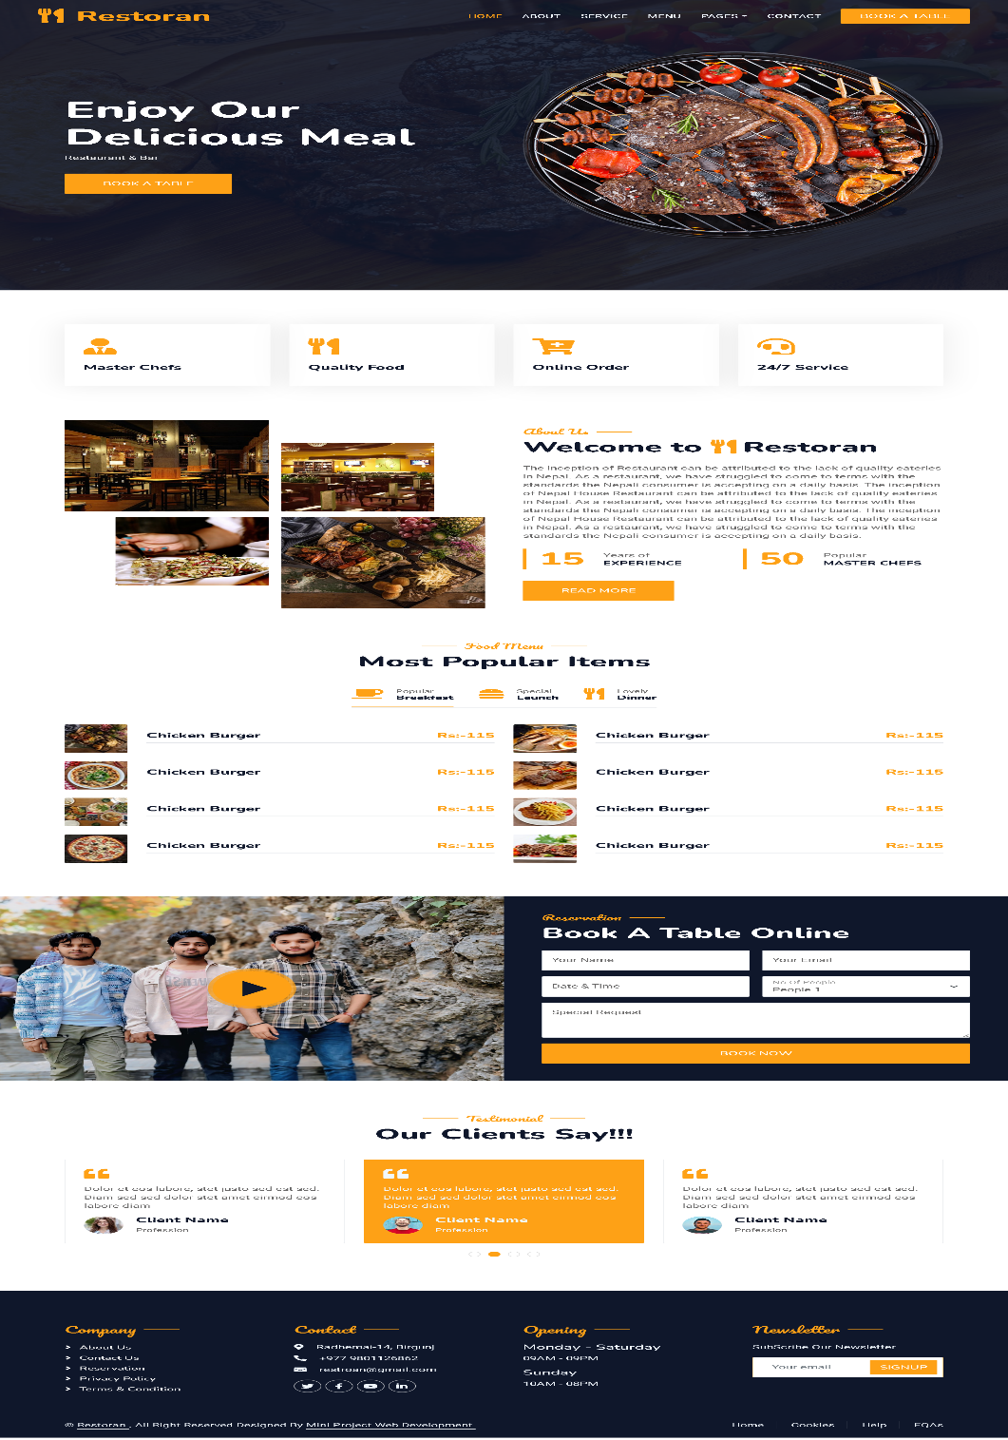

Figure: 3.1The Website

Figure 6 shows the main interface of the website. It shows the home page which include the Owner, staff and Customer.

**3.2 Header**

On the header of this website, it contains One Headers the main header contains the main things which is the Logo of the Website the navigation menu Where the default is the Home menu. Other Menus are also available likes as About Us, Service, Menu, Team, Testimonial, Contact, Booking



Figure: 3.2 Header Section

**3.3 Footer**

This Section is Located Footer of the as the Footer always Located in the footer of the website. In this section, there is **a Restaurant logo** with a **Short description and social media link** at the left side of the page. At the center, **the Means links** are added to visit any page directly from the footer section, and also there is a **gallery section** of our college where all the events and cultural programs events photos are added. At the right side of the footer there **popular tags** section where we have added all the popular visited sections to the footer. After the main Footer, there is also the short footer which contains the copyright information.

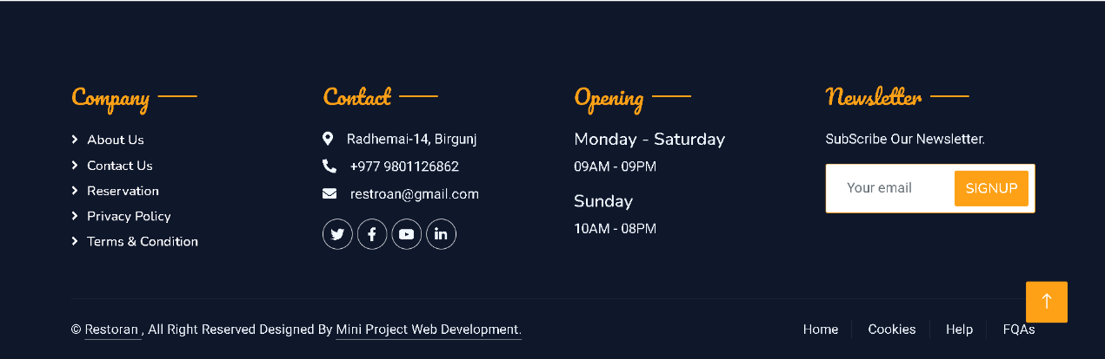

Figure: 3.3 Footer

**3.4 About Page**

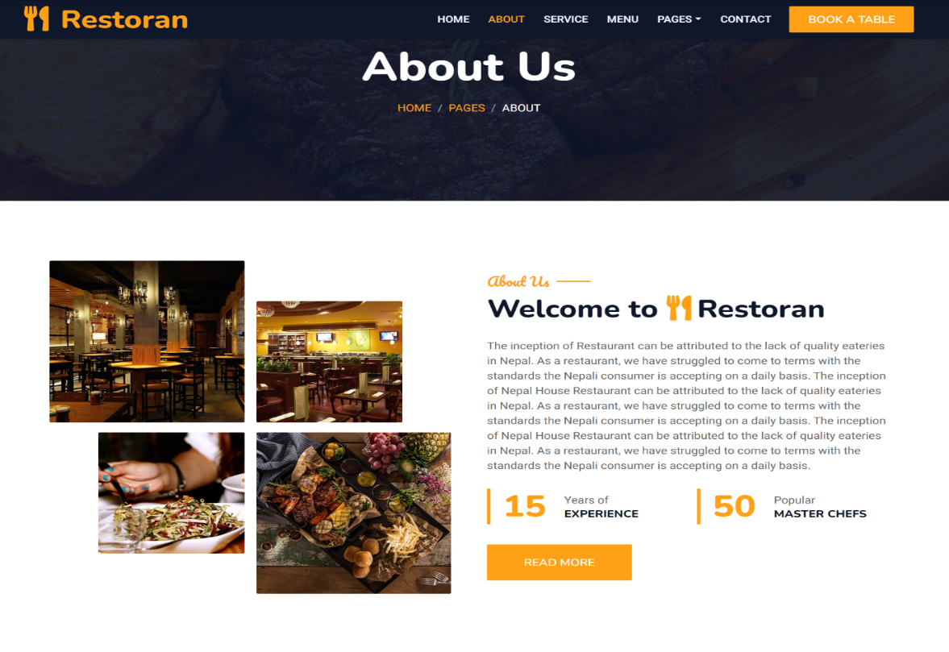

Figure: 3.4 About

**3.5 Service Page**

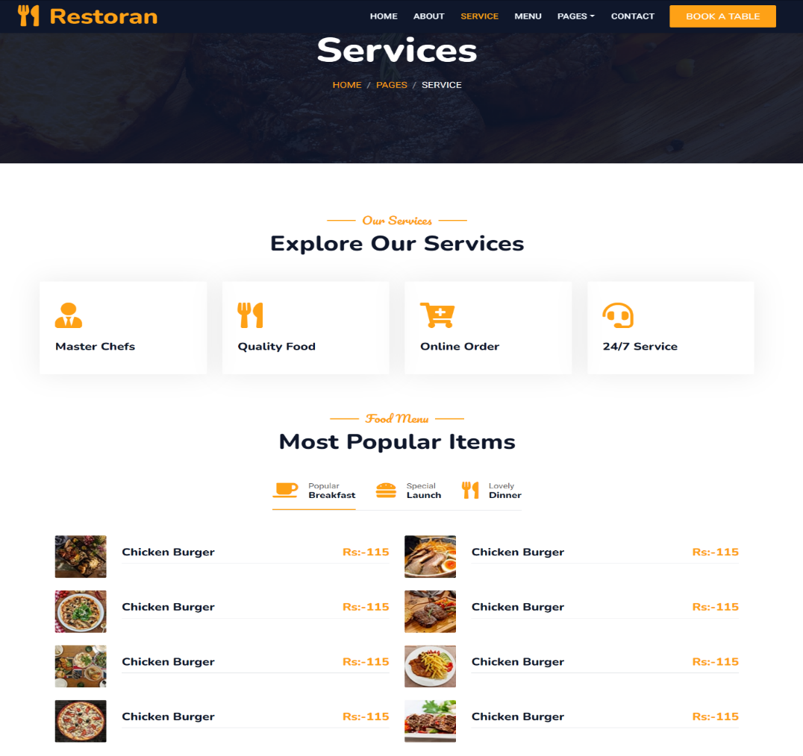

Figure: 3.5 Service Page

**3.6 Menu page**

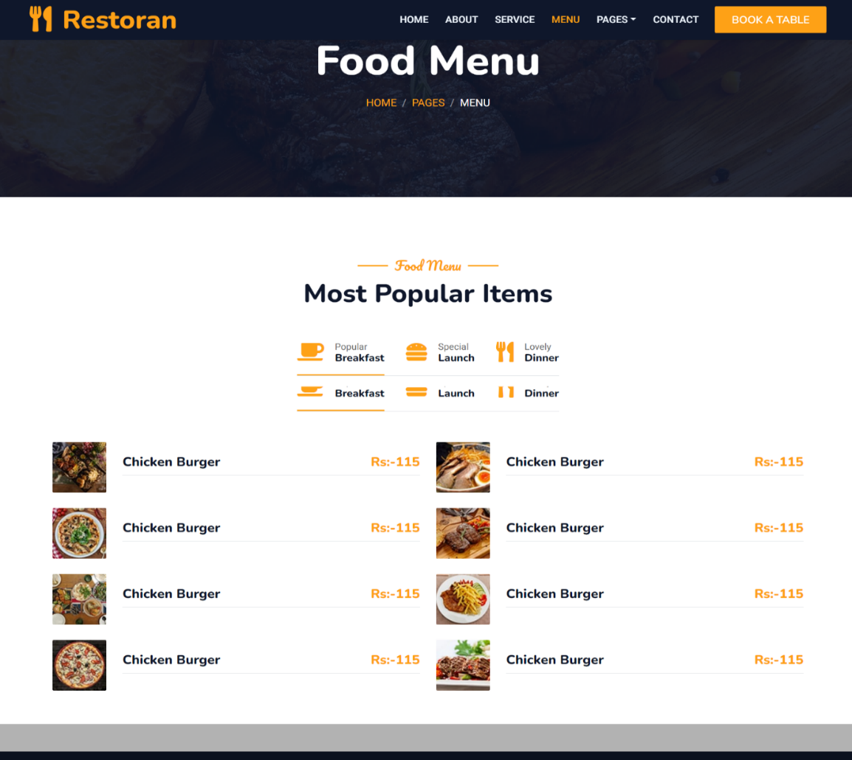

Figure: 3.6 Menu Page

**3.7 Booking Page**

Figure: 3.7 Booking page

**3.9 Contact Page**

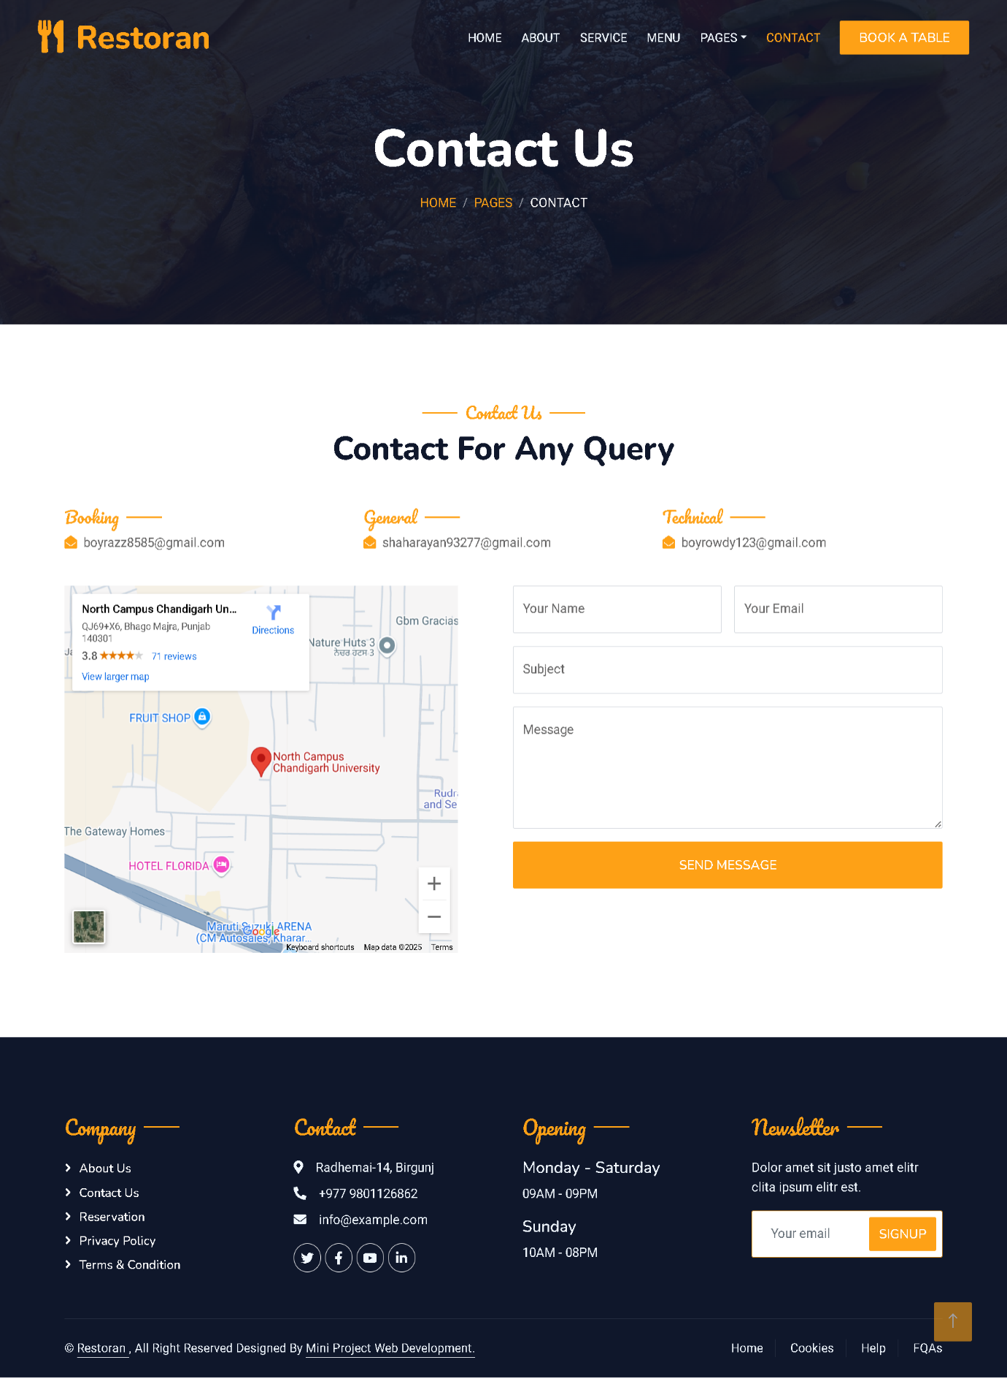

Figure: 3.9 Contact Page

**Code**

**Web Development Program Code**

**There are Different types of pages Code on the website is listed below: -**

**•** **Header**

**•** **Footer**

**•** **About Page**

**•** **Service Page**

**•** **Menu page**

**• Booking Page**

**•** **Contact Page**

**4.1 Header**

**Code**

<div class="container-xxl position-relative p-0">

            <nav class="navbar navbar-expand-lg navbar-dark bg-dark px-4 px-lg-5 py-3 py-lg-0">

                <a href="" class="navbar-brand p-0">

                    <h1 class="text-primary m-0"><i class="fa fa-utensils me-3"></i>Restoran</h1>

                    <!-- <img src="img/logo.png" alt="Logo"> -->

                </a>

                <button class="navbar-toggler" type="button" data-bs-toggle="collapse" data-bs-target="#navbarCollapse">

                    <span class="fa fa-bars"></span>

                </button>

                <div class="collapse navbar-collapse" id="navbarCollapse">

                    <div class="navbar-nav ms-auto py-0 pe-4">

                        <a href="index.html" class="nav-item nav-link active">Home</a>

                        <a href="about.html" class="nav-item nav-link">About</a>

                        <a href="service.html" class="nav-item nav-link">Service</a>

                        <a href="menu.html" class="nav-item nav-link">Menu</a>

                        <div class="nav-item dropdown">

                            <a href="#" class="nav-link dropdown-toggle" data-bs-toggle="dropdown">Pages</a>

                            <div class="dropdown-menu m-0">

                                <a href="booking.html" class="dropdown-item">Booking</a>

<a href="team.html" class="dropdown-item">Our Team</a>

                                <a href="testimonial.html" class="dropdown-item">Testimonial</a>

                            </div>

                        </div>

                        <a href="contact.html" class="nav-item nav-link">Contact</a>

                    </div>

                    <a href="" class="btn btn-primary py-2 px-4">Book A Table</a>

                </div>

            </nav>

            <div class="container-xxl py-5 bg-dark hero-header mb-5">

                <div class="container my-5 py-5">

                    <div class="row align-items-center g-5">

                        <div class="col-lg-6 text-center text-lg-start">

                            <h1 class="display-3 text-white animated slideInLeft">Enjoy Our<br>Delicious Meal</h1>

                            <p class="text-white animated slideInLeft mb-4 pb-2">Restaurant & Bar</p>

                            <a href="" class="btn btn-primary py-sm-3 px-sm-5 me-3 animated slideInLeft">Book A Table</a>

                        </div>

                        <div class="col-lg-6 text-center text-lg-end overflow-hidden">

                            <img class="img-fluid" src="img/hero.png" alt="">

                        </div>

                    </div>

                </div>

            </div>

        </div>

<!--Header-->

**4.2 Footer**

**Code**

<!-- Footer Start -->

        <div class="container-fluid bg-dark text-light footer pt-5 mt-5 wow fadeIn" data-wow-delay="0.1s">

            <div class="container py-5">

                <div class="row g-5">

                    <div class="col-lg-3 col-md-6">

                        <h4 class="section-title ff-secondary text-start text-primary fw-normal mb-4">Company</h4>

                        <a class="btn btn-link" href="">About Us</a>

                        <a class="btn btn-link" href="">Contact Us</a>

                        <a class="btn btn-link" href="">Reservation</a>

                        <a class="btn btn-link" href="">Privacy Policy</a>

Page | 15

<a class="btn btn-link" href="">Terms & Condition</a>

                    </div>

                    <div class="col-lg-3 col-md-6">

                        <h4 class="section-title ff-secondary text-start text-primary fw-normal mb-4">Contact</h4>

                        <p class="mb-2"><i class="fa fa-map-marker-alt me-3"></i>Radhemai-14, Birgunj </p>

                        <p class="mb-2"><i class="fa fa-phone-alt me-3"></i>+977 9801126862</p>

                        <p class="mb-2"><i class="fa fa-envelope me-3"></i>boyrazz8585@gmail.com</p>

                        <div class="d-flex pt-2">

                            <a class="btn btn-outline-light btn-social" href=""><i class="fab fa-twitter"></i></a>

                            <a class="btn btn-outline-light btn-social" href=""><i class="fab fa-facebook-f"></i></a>

                            <a class="btn btn-outline-light btn-social" href=""><i class="fab fa-youtube"></i></a>

                            <a class="btn btn-outline-light btn-social" href=""><i class="fab fa-linkedin-in"></i></a>

                        </div>

                    </div>

<div class="col-lg-3 col-md-6">

                        <h4 class="section-title ff-secondary text-start text-primary fw-normal mb-4">Opening</h4>

                        <h5 class="text-light fw-normal">Monday - Saturday</h5>

                        <p>09AM - 09PM</p>

                        <h5 class="text-light fw-normal">Sunday</h5>

                        <p>10AM - 08PM</p>

                    </div>

                    <div class="col-lg-3 col-md-6">

                        <h4 class="section-title ff-secondary text-start text-primary fw-normal mb-4">Newsletter</h4>

                        <p>SubScribe Our Newsletter.</p>

                        <div class="position-relative mx-auto" style="max-width: 400px;">

                            <input class="form-control border-primary w-100 py-3 ps-4 pe-5" type="text" placeholder="Your email">

                            <button type="button" class="btn btn-primary py-2 position-absolute top-0 end-0 mt-2 me-2">SignUp</button>

                        </div>

                    </div>

                </div>

            </div>

            <div class="container">

                <div class="copyright">

                    <div class="row">

<div class="col-md-6 text-center text-md-start mb-3 mb-md-0">

                            &copy; <a class="border-bottom" href="#">Restoran </a>, All Right Reserved

                            Designed By <a class="border-bottom" href="#">Shree Nrisingh secondary school(Student).</a>

                        </div>

                        <div class="col-md-6 text-center text-md-end">

                            <div class="footer-menu">

                                <a href="">Home</a>

                                <a href="">Cookies</a>

                                <a href="">Help</a>

                                <a href="">FQAs</a>

                            </div>

                        </div>

                    </div>

                </div>

            </div>

        </div>

        <!-- Footer End -->

**4.3 About Page**

**Code**

<!-- About Start -->

        <div class="container-xxl py-5">

            <div class="container">

                <div class="row g-5 align-items-center">

                    <div class="col-lg-6">

                        <div class="row g-3">

                            <div class="col-6 text-start">

                                <img class="img-fluid rounded w-100 wow zoomIn" data-wow-delay="0.1s" src="img/about-1.jpg">

                            </div>

                            <div class="col-6 text-start">

                                <img class="img-fluid rounded w-75 wow zoomIn" data-wow-delay="0.3s" src="img/about-2.jpg" style="margin-top: 25%;">

                            </div>

                            <div class="col-6 text-end">

                                <img class="img-fluid rounded w-75 wow zoomIn" data-wow-delay="0.5s" src="img/about-3.jpg">

                            </div>

                            <div class="col-6 text-end">

                                <img class="img-fluid rounded w-100 wow zoomIn" data-wow-delay="0.7s" src="img/about-4.jpg">

                            </div>

                        </div>

                    </div>

                    <div class="col-lg-6">

<h5 class="section-title ff-secondary text-start text-primary fw-normal">About Us</h5>

                        <h1 class="mb-4">Welcome to <i class="fa fa-utensils text-primary me-2"></i>Restoran</h1>

                        <p class="mb-4">The inception of Restaurant can be attributed to the lack of quality eateries in Nepal. As a restaurant, we have struggled to come to terms with the standards the Nepali consumer is accepting on a daily basis. The inception of Nepal House Restaurant can be attributed to the lack of quality eateries in Nepal. As a restaurant, we have struggled to come to terms with the standards the Nepali consumer is accepting on a daily basis. The inception of Nepal House Restaurant can be attributed to the lack of quality eateries in Nepal. As a restaurant, we have struggled to come to terms with the standards the Nepali consumer is accepting on a daily basis.</p>

                        <div class="row g-4 mb-4">

                            <div class="col-sm-6">

                                <div class="d-flex align-items-center border-start border-5 border-primary px-3">

                                    <h1 class="flex-shrink-0 display-5 text-primary mb-0" data-toggle="counter-up">15</h1>

        </div>

        <!-- About End -->

**4.4 Service Page**

**Code**

 <!-- Service Start -->

        <div class="container-xxl py-5">

            <div class="container">

                <div class="text-center wow fadeInUp" data-wow-delay="0.1s">

                    <h5 class="section-title ff-secondary text-center text-primary fw-normal">Our Services</h5>

                    <h1 class="mb-5">Explore Our Services</h1>

                </div>

                <div class="row g-4">

                    <div class="col-lg-3 col-sm-6 wow fadeInUp" data-wow-delay="0.1s">

                        <div class="service-item rounded pt-3">

                            <div class="p-4">

                                <i class="fa fa-3x fa-user-tie text-primary mb-4"></i>

                                <h5>Master Chefs</h5>

                                <p> </p>

                            </div>

                        </div>

                    </div>

                    <div class="col-lg-3 col-sm-6 wow fadeInUp" data-wow-delay="0.3s">

                        <div class="service-item rounded pt-3">

                            <div class="p-4">

                                <i class="fa fa-3x fa-utensils text-primary mb-4"></i>

                                <h5>Quality Food</h5>

                                <p> </p>

                            </div>

                        </div>

                    </div>

                    <div class="col-lg-3 col-sm-6 wow fadeInUp" data-wow-delay="0.5s">

                        <div class="service-item rounded pt-3">

                            <div class="p-4">

                                <i class="fa fa-3x fa-cart-plus text-primary mb-4"></i>

                                <h5>Online Order</h5>

                                <p> </p>

                            </div>

                        </div>

                    </div>

                    <div class="col-lg-3 col-sm-6 wow fadeInUp" data-wow-delay="0.7s">

                        <div class="service-item rounded pt-3">

                            <div class="p-4">

  <i class="fa fa-3x fa-headset text-primary mb-4"></i>

                                <h5>24/7 Service</h5>

                                <p> </p>

                            </div>

                        </div>

                    </div>

                    <!-- Menu Start -->

        <div class="container-xxl py-5">

            <div

class="container">

                <div class="text-center wow fadeInUp" data-wow-delay="0.1s">

                    <h5 class="section-title ff-secondary text-center text-primary fw-normal">Food Menu</h5>

                    <h1 class="mb-5">Most Popular Items</h1>

                </div>

                <div class="tab-class text-center wow fadeInUp" data-wow-delay="0.1s">

                    <ul class="nav nav-pills d-inline-flex justify-content-center border-bottom mb-5">

                        <li class="nav-item">

                            <a class="d-flex align-items-center text-start mx-3 ms-0 pb-3 active" data-bs-toggle="pill" href="#tab-1">

                                <i class="fa fa-coffee fa-2x text-primary"></i>

                                <div class="ps-3">

                                    <small class="text-body">Popular</small>

                                    <h6 class="mt-n1 mb-0">Breakfast</h6>

                                </div>

                            </a>

                        </li>

                        <li class="nav-item">

                            <a class="d-flex align-items-center text-start mx-3 pb-3" data-bs-toggle="pill" href="#tab-2">

                                <i class="fa fa-hamburger fa-2x text-primary"></i>

                                <div class="ps-3">

                                    <small class="text-body">Special</small>

                                    <h6 class="mt-n1 mb-0">Launch</h6>

                                </div>

                            </a>

                        </li>

                        <li class="nav-item">

                            <a class="d-flex align-items-center text-start mx-3 me-0 pb-3" data-bs-toggle="pill" href="#tab-3">

                                <i class="fa fa-utensils fa-2x text-primary"></i>

<div class="ps-3">

                                    <small class="text-body">Lovely</small>

                                    <h6 class="mt-n1 mb-0">Dinner</h6>

                                </div>

                            </a>

                        </li>

                    </ul>

                    <div class="tab-content">

                        <div id="tab-1" class="tab-pane fade show p-0 active">

                            <div class="row g-4">

                                <div class="col-lg-6">

                                    <div class="d-flex align-items-center">

                                        <img class="flex-shrink-0 img-fluid rounded" src="img/menu-1.jpg" alt="" style="width: 80px;">

                                        <div class="w-100 d-flex flex-column text-start ps-4">

                                            <h5 class="d-flex justify-content-between border-bottom pb-2">

                                                <span>Chicken Burger</span>

                                                <span class="text-primary">Rs:-115</span>

                                            </h5>

                                            <small class="fst-italic"> </small>

                                        </div>

                                    </div>

                                </div>

                                <div class="col-lg-6">

                                    <div class="d-flex align-items-center">

                                        <img class="flex-shrink-0 img-fluid rounded" src="img/menu-2.jpg" alt="" style="width: 80px;">

                                        <div class="w-100 d-flex flex-column text-start ps-4">

                                            <h5 class="d-flex justify-content-between border-bottom pb-2">

                                                <span>Chicken Burger</span>

                                                <span class="text-primary">Rs:-115</span>

                                            </h5>

                                            <small class="fst-italic"> </small>

                                        </div>

                                    </div>

                                </div>

<div class="col-lg-6">

                                    <div class="d-flex align-items-center">

                                        <img class="flex-shrink-0 img-fluid rounded" src="img/menu-3.jpg" alt="" style="width: 80px;">

                                        <div class="w-100 d-flex flex-column text-start ps-4">

                                            <h5 class="d-flex justify-content-between border-bottom pb-2">

                                                <span>Chicken Burger</span>

                                                <span class="text-primary">Rs:-115</span>

                                            </h5>

                                            <small class="fst-italic"> </small>

                                        </div>

                                    </div>

                                </div>

                                <div class="col-lg-6">

                                    <div class="d-flex align-items-center">

                                        <img class="flex-shrink-0 img-fluid rounded" src="img/menu-4.jpg" alt="" style="width: 80px;">

                                        <div class="w-100 d-flex flex-column text-start ps-4">

                                            <h5 class="d-flex justify-content-between border-bottom pb-2">

                                                <span>Chicken Burger</span>

                                                <span class="text-primary">Rs:-115</span>

                                            </h5>

                                            <small class="fst-italic"> </small>

                                        </div>

                                    </div>

                                </div>

                                <div class="col-lg-6">

                                    <div class="d-flex align-items-center">

                                        <img class="flex-shrink-0 img-fluid rounded" src="img/menu-5.jpg" alt="" style="width: 80px;">

                                        <div class="w-100 d-flex flex-column text-start ps-4">

                                            <h5 class="d-flex justify-content-between border-bottom pb-2">

                                                <span>Chicken Burger</span>

                                                <span class="text-primary">Rs:-115</span>

    </h5>

                                            <small class="fst-italic"> </small>

                                        </div>

                                    </div>

                                </div>

                                <div class="col-lg-6">

                                    <div class="d-flex align-items-center">

    <img class="flex-shrink-0 img-fluid rounded" src="img/menu-6.jpg" alt="" style="width: 80px;">

                                        <div class="w-100 d-flex flex-column text-start ps-4">

                                            <h5 class="d-flex justify-content-between border-bottom pb-2">

                                                <span>Chicken Burger</span>

                                                <span class="text-primary">Rs:-115</span>

                                            </h5>

                                            <small class="fst-italic"> </small>

                                        </div>

                                    </div>

                                </div>

                                <div class="col-lg-6">

                                    <div class="d-flex align-items-center">

                                        <img class="flex-shrink-0 img-fluid rounded" src="img/menu-7.jpg" alt="" style="width: 80px;">

                                        <div class="w-100 d-flex flex-column text-start ps-4">

                                            <h5 class="d-flex justify-content-between border-bottom pb-2">

                                                <span>Chicken Burger</span>

                                                <span class="text-primary">Rs:-115</span>

                                            </h5>

                                            <small class="fst-italic"> </small>

                                        </div>

                                    </div>

                                </div>

                                <div class="col-lg-6">

                                    <div class="d-flex align-items-center">

  <img class="flex-shrink-0 img-fluid rounded" src="img/menu-8.jpg" alt="" style="width: 80px;">

                                        <div class="w-100 d-flex flex-column text-start ps-4">

                                            <h5 class="d-flex justify-content-between border-bottom pb-2">

                                                <span>Chicken Burger</span>

                                                <span class="text-primary">Rs:-115</span> </h5>

                                            <small class="fst-italic"> </small>

                                        </div>

                                    </div>

                                </div>

                            </div>

                        </div>

                        <div id="tab-2" class="tab-pane fade show p-0">

                            <div class="row g-4">

                                <div class="col-lg-6">

                                    <div class="d-flex align-items-center">

                                        <img class="flex-shrink-0 img-fluid rounded" src="img/menu-1.jpg" alt="" style="width: 80px;">

                                        <div class="w-100 d-flex flex-column text-start ps-4">

                                            <h5 class="d-flex justify-content-between border-bottom pb-2">

                                                <span>Chicken Burger</span>

                                                <span class="text-primary">Rs:-115</span>

                                            </h5>

                                            <small class="fst-italic"> </small>

                                        </div>

                                    </div>

                                </div>

                                <div class="col-lg-6">

                                    <div class="d-flex align-items-center">

                                        <img class="flex-shrink-0 img-fluid rounded" src="img/menu-2.jpg" alt="" style="width: 80px;">

                                        <div class="w-100 d-flex flex-column text-start ps-4">

                                            <h5 class="d-flex justify-content-between border-bottom pb-2">

<span>Chicken Burger</span><span class="text-primary">Rs:-115</span>

                                            </h5>

                                            <small class="fst-italic"> </small>

                                        </div>

                                    </div>

                                </div>

                                <div class="col-lg-6">

                                    <div class="d-flex align-items-center">

                                        <img class="flex-shrink-0 img-fluid rounded" src="img/menu-3.jpg" alt="" style="width: 80px;">

                                        <div class="w-100 d-flex flex-column text-start ps-4">

                                            <h5 class="d-flex justify-content-between border-bottom pb-2">

                                                <span>Chicken Burger</span>

                                                <span class="text-primary">Rs:-115</span></h5>

                                            <small class="fst-italic"> </small>

                                        </div>

                                    </div>

                                </div>

                                <div class="col-lg-6">

                                    <div class="d-flex align-items-center">

                                        <img class="flex-shrink-0 img-fluid rounded" src="img/menu-4.jpg" alt="" style="width: 80px;">

                                        <div class="w-100 d-flex flex-column text-start ps-4">

                                            <h5 class="d-flex justify-content-between border-bottom pb-2">

                                                <span>Chicken Burger</span>

                                                <span class="text-primary">Rs:-115</span>

                                            </h5>

                                            <small class="fst-italic"> </small>

                                        </div>

                                    </div>

                                </div>

                                <div class="col-lg-6">

<div class="d-flex align-items-center">

                                        <img class="flex-shrink-0 img-fluid rounded" src="img/menu-5.jpg" alt="" style="width: 80px;">

                                        <div class="w-100 d-flex flex-column text-start ps-4">

                                            <h5 class="d-flex justify-content-between border-bottom pb-2">

                                                <span>Chicken Burger</span>

                                                <span class="text-primary">Rs:-115</span>

                                            </h5>

                                            <small class="fst-italic"> </small>

                                        </div>

                                    </div>

                                </div>

                                <div class="col-lg-6">

                                    <div class="d-flex align-items-center">

                                        <img class="flex-shrink-0 img-fluid rounded" src="img/menu-6.jpg" alt="" style="width: 80px;">

                                        <div class="w-100 d-flex flex-column text-start ps-4">

                                            <h5 class="d-flex justify-content-between border-bottom pb-2">

                                                <span>Chicken Burger</span>

                                                <span class="text-primary">Rs:-115</span>

                                            </h5>

                                            <small class="fst-italic"> </small>

                                        </div>

                                    </div>

                                </div>

                                <div class="col-lg-6">

                                    <div class="d-flex align-items-center">

                                        <img class="flex-shrink-0 img-fluid rounded" src="img/menu-7.jpg" alt="" style="width: 80px;">

                                        <div class="w-100 d-flex flex-column text-start ps-4">

                                            <h5 class="d-flex justify-content-between border-bottom pb-2">

                                                <span>Chicken Burger</span>

                                                <span class="text-primary">Rs:-115</span>

    </h5>

                                            <small class="fst-italic"> </small>

                                        </div>

                                    </div>

                                </div>

                                <div class="col-lg-6">

                                    <div class="d-flex align-items-center">

                                        <img class="flex-shrink-0 img-fluid rounded" src="img/menu-8.jpg" alt="" style="width: 80px;">

                                        <div class="w-100 d-flex flex-column text-start ps-4">

                                            <h5 class="d-flex justify-content-between border-bottom pb-2">

                                                <span>Chicken Burger</span>

                                                <span class="text-primary">Rs:-115</span>

                                            </h5>

                                            <small class="fst-italic"> </small>

                                        </div>

                                    </div>

                                </div>

                            </div>

                        </div>

                        <div id="tab-3" class="tab-pane fade show p-0">

                            <div class="row g-4">

                                <div class="col-lg-6">

                                    <div class="d-flex align-items-center">

                                        <img class="flex-shrink-0 img-fluid rounded" src="img/menu-1.jpg" alt="" style="width: 80px;">

                                        <div class="w-100 d-flex flex-column text-start ps-4">

                                            <h5 class="d-flex justify-content-between border-bottom pb-2">

                                                <span>Chicken Burger</span>

                                                <span class="text-primary">Rs:-115</span>

                                            </h5>

                                            <small class="fst-italic"> </small>

                                        </div>

                                    </div>

                                </div>

                                <div class="col-lg-6">

  <div class="d-flex align-items-center">

                                        <img class="flex-shrink-0 img-fluid rounded" src="img/menu-2.jpg" alt="" style="width: 80px;">

                                        <div class="w-100 d-flex flex-column text-start ps-4">

                                            <h5 class="d-flex justify-content-between border-bottom pb-2">

                                                <span>Chicken Burger</span>

                                                <span class="text-primary">Rs:-115</span>

                                            </h5>

        <!-- Service End -->

**4.5 Menu Page**

**Code**

<!-- Menu Start -->

        <div class="container-xxl py-5">

            <div class="container">

                <div class="text-center wow fadeInUp" data-wow-delay="0.1s">

                    <h5 class="section-title ff-secondary text-center text-primary fw-normal">Food Menu</h5>

                    <h1 class="mb-5">Most Popular Items</h1></div>

                <div class="tab-class text-center wow fadeInUp" data-wow-delay="0.1s">

                    <ul class="nav nav-pills d-inline-flex justify-content-center border-bottom mb-5">

                        <li class="nav-item">

                            <a class="d-flex align-items-center text-start mx-3 ms-0 pb-3 active" data-bs-toggle="pill" href="#tab-1">

                                <i class="fa fa-coffee fa-2x text-primary"></i>

                                <div class="ps-3">

                                    <small class="text-body">Popular</small>

                                    <h6 class="mt-n1 mb-0">Breakfast</h6>

                                </div>

                            </a>

                        </li>

                        <li class="nav-item">

                            <a class="d-flex align-items-center text-start mx-3 pb-3" data-bs-toggle="pill" href="#tab-2">

                                <i class="fa fa-hamburger fa-2x text-primary"></i>

                                <div class="ps-3">

                                    <small class="text-body">Special</small>

                                    <h6 class="mt-n1 mb-0">Launch</h6>

                                </div>

                            </a>

                        </li>

                        <li class="nav-item">

                            <a class="d-flex align-items-center text-start mx-3 me-0 pb-3" data-bs-toggle="pill" href="#tab-3">

                                <i class="fa fa-utensils fa-2x text-primary"></i>

                                <div class="ps-3">

                                    <small class="text-body">Lovely</small>

                                    <h6 class="mt-n1 mb-0">Dinner</h6>

                                </div>

                            </a></li>

</ul>

                    <div class="tab-content">

                        <div id="tab-1" class="tab-pane fade show p-0 active">

                            <div class="row g-4">

                                <div class="col-lg-6">

                                    <div class="d-flex align-items-center">

<img class="flex-shrink-0 img-fluid rounded" src="img/menu-1.jpg" alt="" style="width: 80px;">

                                        <div class="w-100 d-flex flex-column text-start ps-4">

                                            <h5 class="d-flex justify-content-between border-bottom pb-2">

                                                <span>Chicken Burger</span>

                                                <span class="text-primary">Rs:-115</span>

                                            </h5>

                                            <small class="fst-italic"> </small>

                                        </div>

                                    </div>

                                </div>

                                <div class="col-lg-6">

                                    <div class="d-flex align-items-center">

                                        <img class="flex-shrink-0 img-fluid rounded" src="img/menu-2.jpg" alt="" style="width: 80px;">

                                        <div class="w-100 d-flex flex-column text-start ps-4">

                                            <h5 class="d-flex justify-content-between border-bottom pb-2">

                                                <span>Chicken Burger</span>

                                                <span class="text-primary">Rs:-115</span>

                                            </h5>

                                            <small class="fst-italic"> </small>

                                        </div>

                                    </div>

                                </div>

                                <div class="col-lg-6">

                                    <div class="d-flex align-items-center">

                                        <img class="flex-shrink-0 img-fluid rounded" src="img/menu-3.jpg" alt="" style="width: 80px;">

                                        <div class="w-100 d-flex flex-column text-start ps-4">

                                            <h5 class="d-flex justify-content-between border-bottom pb-2">

                                                <span>Chicken Burger</span>

                                                <span class="text-primary">Rs:-115</span>

                                            </h5>

                                            <small class="fst-italic"> </small>

  </div>

                                    </div>

                                </div>

                                <div class="col-lg-6">

                                    <div class="d-flex align-items-center">

                                        <img class="flex-shrink-0 img-fluid rounded" src="img/menu-4.jpg" alt="" style="width: 80px;">

                                        <div class="w-100 d-flex flex-column text-start ps-4">

                                            <h5 class="d-flex justify-content-between border-bottom pb-2">

                                                <span>Chicken Burger</span>

                                                <span class="text-primary">Rs:-115</span>

                                            </h5>

                                            <small class="fst-italic"> </small>

                                        </div>

                                    </div>

                                </div>

                                <div class="col-lg-6">

                                    <div class="d-flex align-items-center">

                                        <img class="flex-shrink-0 img-fluid rounded" src="img/menu-5.jpg" alt="" style="width: 80px;">

                                        <div class="w-100 d-flex flex-column text-start ps-4">

                                            <h5 class="d-flex justify-content-between border-bottom pb-2">

                                                <span>Chicken Burger</span>

                                                <span class="text-primary">Rs:-115</span>

                                            </h5>

                                            <small class="fst-italic"> </small>

                                        </div>

                                    </div>

                                </div>

                                <div class="col-lg-6">

                                    <div class="d-flex align-items-center">

                                        <img class="flex-shrink-0 img-fluid rounded" src="img/menu-6.jpg" alt="" style="width: 80px;">

                                        <div class="w-100 d-flex flex-column text-start ps-4">

            <h5 class="d-flex justify-content-between border-bottom pb-2">

<span>Chicken Burger</span>

                                                <span class="text-primary">Rs:-115</span>

                                            </h5>

                                            <small class="fst-italic"> </small>

                                        </div>

                                    </div>

                                </div>

                                <div class="col-lg-6">

                                    <div class="d-flex align-items-center">

                                        <img class="flex-shrink-0 img-fluid rounded" src="img/menu-7.jpg" alt="" style="width: 80px;">

                                        <div class="w-100 d-flex flex-column text-start ps-4">

                                            <h5 class="d-flex justify-content-between border-bottom pb-2">

                                                <span>Chicken Burger</span>

                                                <span class="text-primary">Rs:-115</span>

                                            </h5>

                                            <small class="fst-italic"> </small>

                                        </div>

                                    </div>

                                </div>

                                <div class="col-lg-6">

                                    <div class="d-flex align-items-center">

                                        <img class="flex-shrink-0 img-fluid rounded" src="img/menu-8.jpg" alt="" style="width: 80px;">

                                        <div class="w-100 d-flex flex-column text-start ps-4">

                                            <h5 class="d-flex justify-content-between border-bottom pb-2">

                                                <span>Chicken Burger</span>

                                                <span class="text-primary">Rs:-115</span>

</h5>

                                            <small class="fst-italic"> </small>

                                        </div>

                                    </div>

                                </div>

      </div>

                        </div>

                        <div id="tab-2" class="tab-pane fade show p-0">

                            <div class="row g-4">

                                <div class="col-lg-6">

                                    <div class="d-flex align-items-center">

                                        <img class="flex-shrink-0 img-fluid rounded" src="img/menu-1.jpg" alt="" style="width: 80px;">

                                        <div class="w-100 d-flex flex-column text-start ps-4">

                                            <h5 class="d-flex justify-content-between border-bottom pb-2">

                                                <span>Chicken Burger</span>

                                                <span class="text-primary">Rs:-115</span>

                                            </h5>

                                            <small class="fst-italic"> </small>

                                        </div>

                                    </div>

                                </div>

                                <div class="col-lg-6">

                                    <div class="d-flex align-items-center">

                                        <img class="flex-shrink-0 img-fluid rounded" src="img/menu-2.jpg" alt="" style="width: 80px;">

                                        <div class="w-100 d-flex flex-column text-start ps-4">

                                            <h5 class="d-flex justify-content-between border-bottom pb-2">

                                                <span>Chicken Burger</span>

                                                <span class="text-primary">Rs:-115</span>

                                            </h5>

                                            <small class="fst-italic"> </small>

                                        </div>

                                    </div>

                                </div>

                              <div class="col-lg-6">

<div class="d-flex align-items-center">

                                        <img class="flex-shrink-0 img-fluid rounded" src="img/menu-3.jpg" alt="" style="width: 80px;">

                                        <div class="w-100 d-flex flex-column text-start ps-4">

<h5 class="d-flex justify-content-between border-bottom pb-2">

                                                <span>Chicken Burger</span>

                                                <span class="text-primary">Rs:-115</span>

                                            </h5>

                                            <small class="fst-italic"> </small>

                                        </div>

                                    </div>

                                </div>

                                <div class="col-lg-6">

                                    <div class="d-flex align-items-center">

                                        <img class="flex-shrink-0 img-fluid rounded" src="img/menu-4.jpg" alt="" style="width: 80px;">

                                        <div class="w-100 d-flex flex-column text-start ps-4">

                                            <h5 class="d-flex justify-content-between border-bottom pb-2">

                                                <span>Chicken Burger</span>

                                                <span class="text-primary">Rs:-115</span>

                                            </h5>

                                            <small class="fst-italic"> </small>

                                        </div>

                                    </div>

                                </div>

                                <div class="col-lg-6">

                                    <div class="d-flex align-items-center">

                                        <img class="flex-shrink-0 img-fluid rounded" src="img/menu-5.jpg" alt="" style="width: 80px;">

                                        <div class="w-100 d-flex flex-column text-start ps-4">

                                            <h5 class="d-flex justify-content-between border-bottom pb-2">

                                                <span>Chicken Burger</span>

                                                <span class="text-primary">Rs:-115</span>

  </h5>

                                            <small class="fst-italic"> </small>

                                        </div>

                                    </div>

                                </div>

<div class="col-lg-6">

                                    <div class="d-flex align-items-center">

                                        <img class="flex-shrink-0 img-fluid rounded" src="img/menu-6.jpg" alt="" style="width: 80px;">

                                        <div class="w-100 d-flex flex-column text-start ps-4">

                                            <h5 class="d-flex justify-content-between border-bottom pb-2">

                                                <span>Chicken Burger</span>

                                                <span class="text-primary">Rs:-115</span>

                                            </h5>

                                            <small class="fst-italic"> </small>

                                        </div>

                                    </div>

                                </div>

                                <div class="col-lg-6">

                                    <div class="d-flex align-items-center">

                                        <img class="flex-shrink-0 img-fluid rounded" src="img/menu-7.jpg" alt="" style="width: 80px;">

                                        <div class="w-100 d-flex flex-column text-start ps-4">

                                            <h5 class="d-flex justify-content-between border-bottom pb-2">

                                                <span>Chicken Burger</span>

                                                <span class="text-primary">Rs:-115</span>

                                            </h5>

                                            <small class="fst-italic"> </small>

                                        </div>

        <!-- Menu End -->

**4.6 Booking Page**

**Code**

 <!-- Reservation Start -->

        <div class="container-xxl py-5 px-0 wow fadeInUp" data-wow-delay="0.1s">

            <div class="row g-0">

                <div class="col-md-6">

                    <div class="video">

                        <button type="button" class="btn-play" data-bs-toggle="modal" data-src="https://www.youtube.com/embed/DWRcNpR6Kdc" data-bs-target="#videoModal">

                            <span></span>

                        </button>

                    </div>

                </div>

                <div class="col-md-6 bg-dark d-flex align-items-center">

                    <div class="p-5 wow fadeInUp" data-wow-delay="0.2s">

                        <h5 class="section-title ff-secondary text-start text-primary fw-normal">Reservation</h5>

                        <h1 class="text-white mb-4">Book A Table Online</h1>

                        <form>

                            <div class="row g-3">

                                <div class="col-md-6">

                                    <div class="form-floating">

                                        <input type="text" class="form-control" id="name" placeholder="Your Name">

                                        <label for="name">Your Name</label>

                                    </div>

                                </div>

                                <div class="col-md-6">

  <div class="form-floating">

                                        <input type="email" class="form-control" id="email" placeholder="Your Email">

                                        <label for="email">Your Email</label>

                                    </div>

                                </div>

                                <div class="col-md-6">

                                    <div class="form-floating date" id="date3" data-target-input="nearest">

                                        <input type="text" class="form-control datetimepicker-input" id="datetime" placeholder="Date & Time" data-target="#date3" data-toggle="datetimepicker" />

                                        <label for="datetime">Date & Time</label>

                                    </div>    </div>

                                <div class="col-md-6">

                                    <div class="form-floating">

                                        <select class="form-select" id="select1">

                                          <option value="1">People 1</option>

                                          <option value="2">People 2</option>

                                          <option value="3">People 3</option>

                                        </select>

                                        <label for="select1">No Of People</label>

                                      </div>

                                </div>

                                <div class="col-12">

                                    <div class="form-floating">

                                        <textarea class="form-control" placeholder="Special Request" id="message" style="height: 100px"></textarea>

                                        <label for="message">Special Request</label>

                                    </div>

                                </div>

                                <div class="col-12">

                                    <button class="btn btn-primary w-100 py-3" type="submit">Book Now</button>

                                </div>

                            </div>

                        </form></div>

                </div></div></div>

<div class="modal fade" id="videoModal" tabindex="-1" aria-labelledby="exampleModalLabel" aria-hidden="true">

            <div class="modal-dialog">

                <div class="modal-content rounded-0">

                    <div class="modal-header">

                        <h5 class="modal-title" id="exampleModalLabel">Youtube Video</h5>

                        <button type="button" class="btn-close" data-bs-dismiss="modal" aria-label="Close"></button></div>

                    <div class="modal-body">

                        <!-- 16:9 aspect ratio -->

                        <div class="ratio ratio-16x9">

                            <iframe class="embed-responsive-item" src="" id="video" allowfullscreen allowscriptaccess="always"

                                allow="autoplay"></iframe>

                        </div></div> </div></div></div>

        <!-- Reservation Start -->

**4.8 Contact Page**

**Code**

<!-- Contact Start -->

        <div class="container-xxl py-5">

            <div class="container">

<div class="text-center wow

fadeInUp" data-wow-delay="0.1s">

                    <h5 class="section-title ff-secondary text-center text-primary fw-normal">Contact Us</h5>

<h1 class="mb-5">Contact For Any Query</h1></div><div class="row g-4">

<div class="col-12">

                        <div class="row gy-4">

                            <div class="col-md-4">

                                <h5 class="section-title ff-secondary fw-normal text-start text-primary">Booking</h5>

                                <p><i class="fa fa-envelope-open text-primary me-2"></i>boyrazz8585@gmail.com</p>

                            </div>

                            <div class="col-md-4">

                                <h5 class="section-title ff-secondary fw-normal text-start text-primary">General</h5>

                                <p><i class="fa fa-envelope-open text-primary me-2"></i>shaharayan93277@gmail.com</p>

                            </div>

                            <div class="col-md-4">

                                <h5 class="section-title ff-secondary fw-normal text-start text-primary">Technical</h5>

                                <p><i class="fa fa-envelope-open text-primary me-2"></i>boyrowdy123@gmail.com</p>

                            </div>

                        </div>

                    </div>

                    <div class="col-md-6 wow fadeIn" data-wow-delay="0.1s">

                        <iframe class="position-relative rounded w-100 h-100"

                            src="https://www.google.com/maps/embed?pb=!1m18!1m12!1m3!1d5173.320515304816!2d84.8984888755982!3d27.031706451569253!2m3!1f0!2f0!3f0!3m2!1i1024!2i768!4f13.1!3m3!1m2!1s0x399354fff20faa83%3A0x7d1230fbea297827!2sShree%20Nrisingh%20Higher%20Secondary%20School!5e0!3m2!1sen!2snp!4v1670482228784!5m2!1sen!2snp"

                            frameborder="0" style="min-height: 350px; border:0;" allowfullscreen="" aria-hidden="false"

                            tabindex="0"></iframe>

                    </div>

                    <div class="col-md-6">

                        <div class="wow fadeInUp" data-wow-delay="0.2s">

                            <form>

                                <div class="row g-3">

                                    <div class="col-md-6">

                                        <div class="form-floating">

<input type="text" class="form-control" id="name" placeholder="Your Name">

                                            <label for="name">Your Name</label></div></div><div class="col-md-6"><div class="form-floating">

                                            <input type="email" class="form-control" id="email" placeholder="Your Email">

<label for="email">Your Email</label></div></div>

 <div class="col-12"><div class="form-floating">

 <input type="text" class="form-control" id="subject"

placeholder="Subject">

                                            <label for="subject">Subject</label>

                                        </div>

                                    </div>

                                    <div class="col-12">

                                        <div class="form-floating">

                                            <textarea class="form-control" placeholder="Leave a message here" id="message" style="height: 150px"></textarea>

                                            <label for="message">Message</label>

                                        </div>

                                    </div>

                                    <div class="col-12">

                                        <button class="btn btn-primary w-100 py-3" type="submit">Send Message</button></div> </div>

   </form></div>

   </div></div></div>

        </div>

        <!-- Contact End -->

**4.9 CSS**

/********* CSS **********/

:root {

    --primary: #FEA116;

    --light: #F1F8FF;

    --dark: #0F172B;

}

.ff-secondary {

    font-family: 'Pacifico', cursive;

}

.fw-medium {

    font-weight: 600 !important;

}

.fw-semi-bold {

    font-weight: 700 !important;

}

.back-to-top {

    position: fixed;

    display: none;

    right: 45px;

    bottom: 45px;

    z-index: 99;

}

/*** Spinner ***/

#spinner {

    opacity: 0;

    visibility: hidden;

    transition: opacity .5s ease-out, visibility 0s linear .5s;

    z-index: 99999;

}

#spinner.show {

    transition: opacity .5s ease-out, visibility 0s linear 0s;

    visibility: visible;

    opacity: 1;

}

/*** Button ***/

.btn {

    font-family: 'Nunito', sans-serif;

    font-weight: 500;

    text-transform: uppercase;

    transition: .5s;

}

.btn.btn-primary,

.btn.btn-secondary {

    color: #FFFFFF;

}

.btn-square {

    width: 38px;

    height: 38px;

}

.btn-sm-square {

    width: 32px;

    height: 32px;

}

.btn-lg-square {

    width: 48px;

    height: 48px;

}

.btn-square,

.btn-sm-square,

.btn-lg-square {

    padding: 0;

    display: flex;

    align-items: center;

    justify-content: center;

  font-weight: normal;

    border-radius: 2px;

}

/*** Navbar ***/

.navbar-dark .navbar-nav .nav-link {

    position: relative;

    margin-left: 25px;

    padding: 35px 0;

    font-size: 15px;

    color: var(--light) !important;

    text-transform: uppercase;

    font-weight: 500;

    outline: none;

    transition: .5s;

}

.sticky-top.navbar-dark .navbar-nav .nav-link {

    padding: 20px 0;

}

.navbar-dark .navbar-nav .nav-link:hover,

.navbar-dark .navbar-nav .nav-link.active {

    color: var(--primary) !important;

}

.navbar-dark .navbar-brand img {

max-height: 60px;

    transition: .5s;

}

.sticky-top.navbar-dark .navbar-brand img {

    max-height: 45px;

}

@media (max-width: 991.98px) {

    .sticky-top.navbar-dark {

        position: relative;

    }

    .navbar-dark .navbar-collapse {

        margin-top: 15px;

        border-top: 1px solid rgba(255, 255, 255, .1)

    }

.navbar-dark .navbar-nav .nav-link,

    .sticky-top.navbar-dark .navbar-nav .nav-link {

        padding: 10px 0;

        margin-left: 0;

}

    .navbar-dark .navbar-brand img {

        max-height: 45px;

    }

}

@media (min-width: 992px) {

    .navbar-dark {

        position: absolute;

        width: 100%;

        top: 0;

        left: 0;

        z-index: 999;

        background: transparent !important;

    }

    .sticky-top.navbar-dark {

        position: fixed;

        background: var(--dark) !important;

    }

}

/*** Hero Header ***/

.hero-header {

    background: linear-gradient(rgba(15, 23, 43, .9), rgba(15, 23, 43, .9)), url(../img/bg-hero.jpg);

    background-position: center center;

    background-repeat: no-repeat;

    background-size: cover;

}

.hero-header img {

    animation: imgRotate 50s linear infinite;

}

@keyframes imgRotate {

    100% {

        transform: rotate(360deg);

    }

}

.breadcrumb-item + .breadcrumb-item::before {

    color: rgba(255, 255, 255, .5);

}

/*** Section Title ***/

.section-title {

    position: relative;

    display: inline-block;

}

.section-title::before {

    position: absolute;

content: "";

    width: 45px;

    height: 2px;

    top: 50%;

    left: -55px;

    margin-top: -1px;

    background: var(--primary);

}

.section-title::after {

    position: absolute;

    content: "";

    width: 45px;

    height: 2px;

    top: 50%;

    right: -55px;

    margin-top: -1px;

    background: var(--primary);

}

.section-title.text-start::before,

.section-title.text-end::after {

    display: none;

}

/*** Service ***/

.service-item {

    box-shadow: 0 0 45px rgba(0, 0, 0, .08);

    transition: .5s;

}

.service-item:hover {

    background: var(--primary);

}

.service-item * {

    transition: .5s;

}

.service-item:hover * {

    color: var(--light) !important;

}

/*** Food Menu ***/

.nav-pills .nav-item .active {

    border-bottom: 2px solid var(--primary);

}

/*** Youtube Video ***/

.video {

    position: relative;

    height: 100%;

    min-height: 500px;

    background: linear-gradient(rgba(15, 23, 43, .1), rgba(15, 23, 43, .1)), url(../img/video.jpg);

    background-position: center center;

    background-repeat: no-repeat;

    background-size: cover;

}

.video .btn-play {

    position: absolute;

    z-index: 3;

    top: 50%;

    left: 50%;

    transform: translateX(-50%) translateY(-50%);

    box-sizing: content-box;

    display: block;

    width: 32px;

    height: 44px;

    border-radius: 50%;

    border: none;

    outline: none;

    padding: 18px 20px 18px 28px;

}

.video .btn-play:before {

    content: "";

    position: absolute;

    z-index: 0;

    left: 50%;

    top: 50%;

    transform: translateX(-50%) translateY(-50%);

    display: block;

    width: 100px;

    height: 100px;

    background: var(--primary);

    border-radius: 50%;

    animation: pulse-border 1500ms ease-out infinite;

}

.video .btn-play:after {

    content: "";

    position: absolute;

    z-index: 1;

    left: 50%;

    top: 50%;

transform: translateX(-50%) translateY(-50%);

display: block;

    width: 100px;

    height: 100px;

    background: var(--primary);

    border-radius: 50%;

    transition: all 200ms;

}

.video .btn-play img {

    position: relative;

    z-index: 3;

    max-width: 100%;

    width: auto;

    height: auto;

}

.video .btn-play span {

    display: block;

    position: relative;

    z-index: 3;

    width: 0;

    height: 0;

    border-left: 32px solid var(--dark);

    border-top: 22px solid transparent;

    border-bottom: 22px solid transparent;

}

@keyframes pulse-border {

    0% {

        transform: translateX(-50%) translateY(-50%) translateZ(0) scale(1);

        opacity: 1;

    }

    100% {

        transform: translateX(-50%) translateY(-50%) translateZ(0) scale(1.5);

        opacity: 0;

    }

}

#videoModal {

    z-index: 99999;

}

#videoModal .modal-dialog {

    position: relative;

    max-width: 800px;

margin: 60px auto 0 auto;

}

#videoModal .modal-body {

    position: relative;

    padding: 0px;

}

#videoModal .close {

    position: absolute;

    width: 30px;

    height: 30px;

    right: 0px;

    top: -30px;

    z-index: 999;

    font-size: 30px;

    font-weight: normal;

    color: #FFFFFF;

    background: #000000;

    opacity: 1;

}

/*** Team ***/

.team-item {

    box-shadow: 0 0 50px rgba(0, 0, 0, .08);

    height: calc(100% - 60px);

    transition: .8s;

    align-items: center;

}

.team-item img {

    transition: .4s;

    align-items: center;

}

.team-item:hover img {

    transform: scale(1.1);

    align-items: center;

}

.team-item:hover {

    height: 100%;

    align-items: center;

}

.team-item .btn {

    border-radius: 50px 50px 0 0;

align-items: center;

}

/*** Testimonial ***/

.testimonial-carousel .owl-item .testimonial-item,

.testimonial-carousel .owl-item.center .testimonial-item * {

    transition: .5s;

}

.testimonial-carousel .owl-item.center .testimonial-item {

    background: var(--primary) !important;

    border-color: var(--primary) !important;

}

.testimonial-carousel .owl-item.center .testimonial-item * {

    color: var(--light) !important;

}

.testimonial-carousel .owl-dots {

    margin-top: 24px;

    display: flex;

    align-items: flex-end;

    justify-content: center;

}

.testimonial-carousel .owl-dot {

    position: relative;

    display: inline-block;

    margin: 0 5px;

    width: 15px;

    height: 15px;

border: 1px solid #CCCCCC;

    border-radius: 15px;

    transition: .5s;

}

.testimonial-carousel .owl-dot.active {

    background: var(--primary);

    border-color: var(--primary);

}

/*** Footer ***/

.footer .btn.btn-social {

    margin-right: 5px;

    width: 35px;

    height: 35px;

    display: flex;

    align-items: center;

justify-content: center;

    color: var(--light);

    border: 1px solid #FFFFFF;

    border-radius: 35px;

    transition: .3s;

}

.footer .btn.btn-social:hover {

    color: var(--primary);

}

.footer .btn.btn-link {

    display: block;

    margin-bottom: 5px;

    padding: 0;

    text-align: left;

    color: #FFFFFF;

    font-size: 15px;

    font-weight: normal;

    text-transform: capitalize;

    transition: .3s;

}

.footer .btn.btn-link::before {

    position: relative;

    content: "\f105";

    font-family: "Font Awesome 5 Free";

    font-weight: 900;

    margin-right: 10px;

}

.footer .btn.btn-link:hover {

    letter-spacing: 1px;

box-shadow: none;

}

.footer .copyright {

    padding: 25px 0;

    font-size: 15px;

    border-top: 1px solid rgba(256, 256, 256, .1);

}

.footer .copyright a {

    color: var(--light);

}

.footer .footer-menu a {

    margin-right: 15px;

    padding-right: 15px;

    border-right: 1px solid rgba(255, 255, 255, .1);

}

.footer .footer-menu a:last-child {

margin-right: 0;

    padding-right: 0;

    border-right: none;

}

**Some Link Used in:**

 <!-- Google Web Fonts -->

    <link rel="preconnect" href="https://fonts.googleapis.com">

    <link rel="preconnect" href="https://fonts.gstatic.com" crossorigin>

href="https://fonts.googleapis.com/css2?family=Heebo:wght@400;500;600&family=Nunito:wght@600;700;800&family=Pacifico&display=swap" rel="stylesheet" <!-- Icon Font Stylesheet -->

    <link href="https://cdnjs.cloudflare.com/ajax/libs/font-awesome/5.10.0/css/all.min.css" rel="stylesheet">

    <link href="https://cdn.jsdelivr.net/npm/bootstrap-icons@1.4.1/font/bootstrap-icons.css" rel="stylesheet">

    <!-- Libraries Stylesheet -->

    <link href="lib/animate/animate.min.css" rel="stylesheet">

    <link href="lib/owlcarousel/assets/owl.carousel.min.css" rel="stylesheet">

    <link href="lib/tempusdominus/css/tempusdominus-bootstrap-4.min.css" rel="stylesheet" />

    <!-- Customized Bootstrap Stylesheet -->

    <link href="css/bootstrap.min.css" rel="stylesheet">

**CHAPTER -5**

**Conclusion**

**5.1 Conclusion**

In this paper, the design of the Restaurant website is presented. Opinions that have been asked gives a positive feedback in making the website. In addition, the client finds the proposed system more effective in their Restaurant by disseminating information's and with Customers awareness and also due to the increased of efficiency by reducing manual posting of announcements and information's. Finally, it is recommended to automate other manual transactions to improve productivity for the client As we all know, our country is a developing country, and it dreams to be a developed country soon. Hence the government of Nepal has taken many necessary projects to fulfill the concept of digital Nepal. Day by day our job sector is getting more and more competitive. As a result, every other company is searching for experienced candidates. Finally, I can claim it's an internship that helps me gain experience. Thanks to Shree Nrisingh Madhyamik Vidyalaya, I gained so much more in-depth knowledge of technical skills and personal skills. This project helped me gather theoretical and practical knowledge about HTML4/5, CSS, JavaScript, Bootstrap, and other programming languages. Beforehand I was confident about designing and developing the frontend of websites. Now I am also confident and competent in backbends. For those students who are willing to work in web development, there are huge opportunities available. To give them the scope for online work and the development of websites, most private and public organizations employ web designers. With the rapid emergence of the digital industry, web development professionals' demand is growing, and in the coming days, this has already availed so many job opportunities for newcomers. My internship company gave me a good scope to learn and discover my potential. I am very grateful to them. No cane to Design Different Website CMD websites. I was fortunate for getting the chance to meet the real-life software development environment.